**ExperimentNo.1.4**

**Student Name:** Gaurav Kumar **UID:** 22MCC20177

**Branch:** MCA**–**CCD **Section/Group:** MCD-1/A

**Semester:** III **Date of Performance: 6**th Oct 23

**Subject Name:** DevOps Process Automation Lab **Subject Code:** 22CAP-745

1. **Aim/Overview of the practical:**
2. Install and configure Jenkins and Java 17.
3. Creating admin Jenkins user and touring the Jenkins dashboard.
4. **Steps for practical: (a)**
5. Open the Internet browser and go to **Jenkins** site and select your **OS**. In my case it’s **Ubuntu**.
6. First add the Jenkins key to your system using this command

curl -fsSL https://pkg.jenkins.io/debian-stable/jenkins.io-2023.key | sudo tee \ /usr/share/keyrings/jenkins-keyring.asc > /dev/null

1. Then add a Jenkins apt repository entry using this command.

echo deb [signed-by=/usr/share/keyrings/jenkins-keyring.asc] \

https://pkg.jenkins.io/debian-stable binary/ | sudo tee \

/etc/apt/sources.list.d/jenkins.list > /dev/null

1. After adding Jenkins Key and repository,Update your local package index, then finally Install Jenkins using bellow commands also install java LTS version 11 or 17.

sudo apt-get update

sudo apt-get install fontconfig openjdk-17-jre

sudo apt-get install jenkins

**Steps for practical: (b)**

1. After successful install open Jenkins in a browse on desire port like localhost:8080.
2. It will ask for Jenkins password. You can find the password on the display path. Use cat command to display the password inside initialAdminPassword file.  
   sudo cat /var/lib/jenkins/secrets/initialAdminPassword

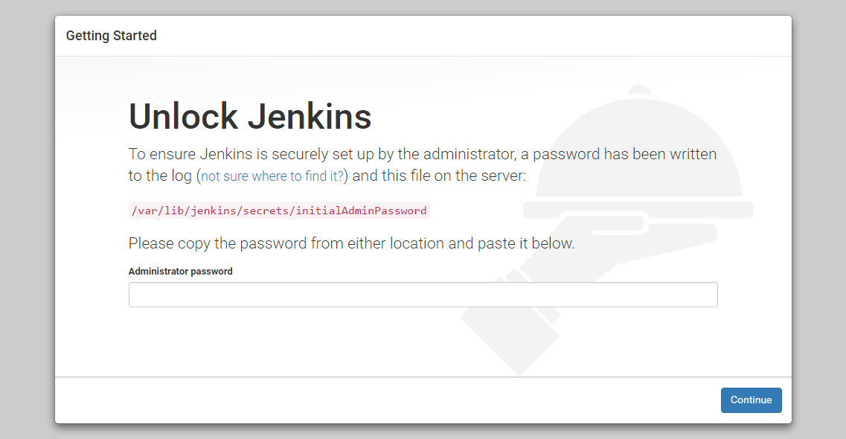

1. Enter initial password and setup the login account. After that install the required plugins.

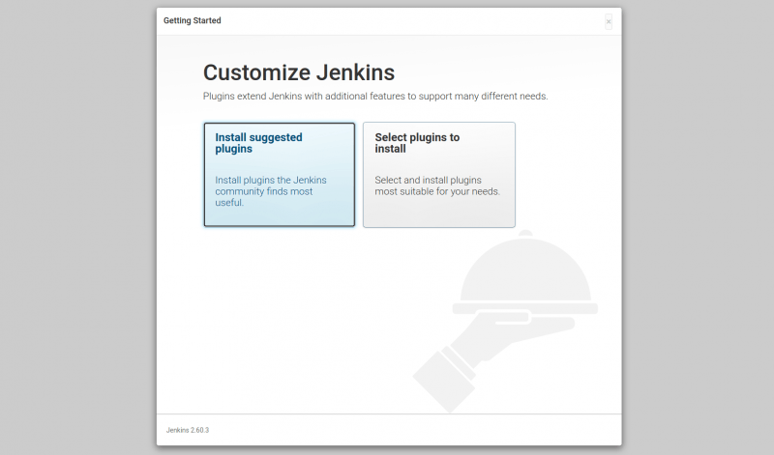

1. After that restart Jenkins. Re-login again.
2. You will land on the Jenkins dashboard.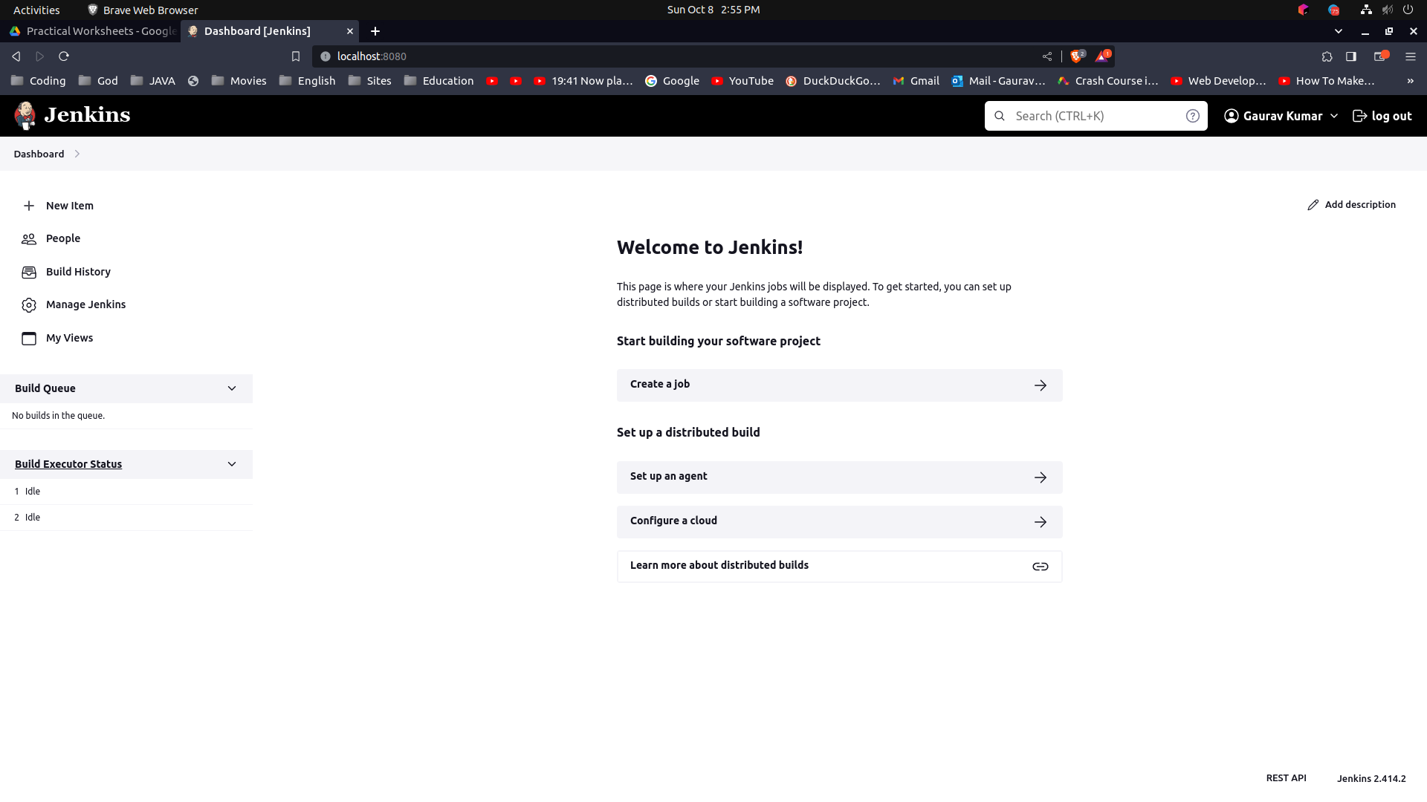
   1. **Header Navigation:** At the top of the Dashboard, you'll find navigation links that allow you to access different sections of Jenkins. This might include links like "New Item" to create new build jobs, "Build History" to see recent builds, "People" for user management, and "Manage Jenkins" for global configuration.
   2. **Main Overview Area:** The main area of the Dashboard Overview typically displays a summarized view of your recent build jobs, pipelines, and their status. Here's what you might find:
      1. **Build Jobs List:** A list of your recent build jobs, each represented by a card or a row. You'll see the job name, build status (success, failure, building), and build number.
      2. **Job Health Indicators:** Visual indicators, such as colored icons or circles, represent the health of each job. For example, a green check mark for success, a red cross for failure, and a blue circle for ongoing builds.
      3. **Pending Builds:** If any build jobs are queued or waiting to be executed, they might be displayed here.
      4. **Quick Actions:** Buttons or links that allow you to trigger a build for a specific job, view job configuration, and access build details.